4.2 Guided Practice: CRUD Application - Creating and Reading

Christopher Crayton
ECPI University
SDC360: Web Application Development
Mohammad Zakaria
March 29, 2026

4.2 Guided Practice: CRUD Application - Creating and Reading
Delete Button Display:
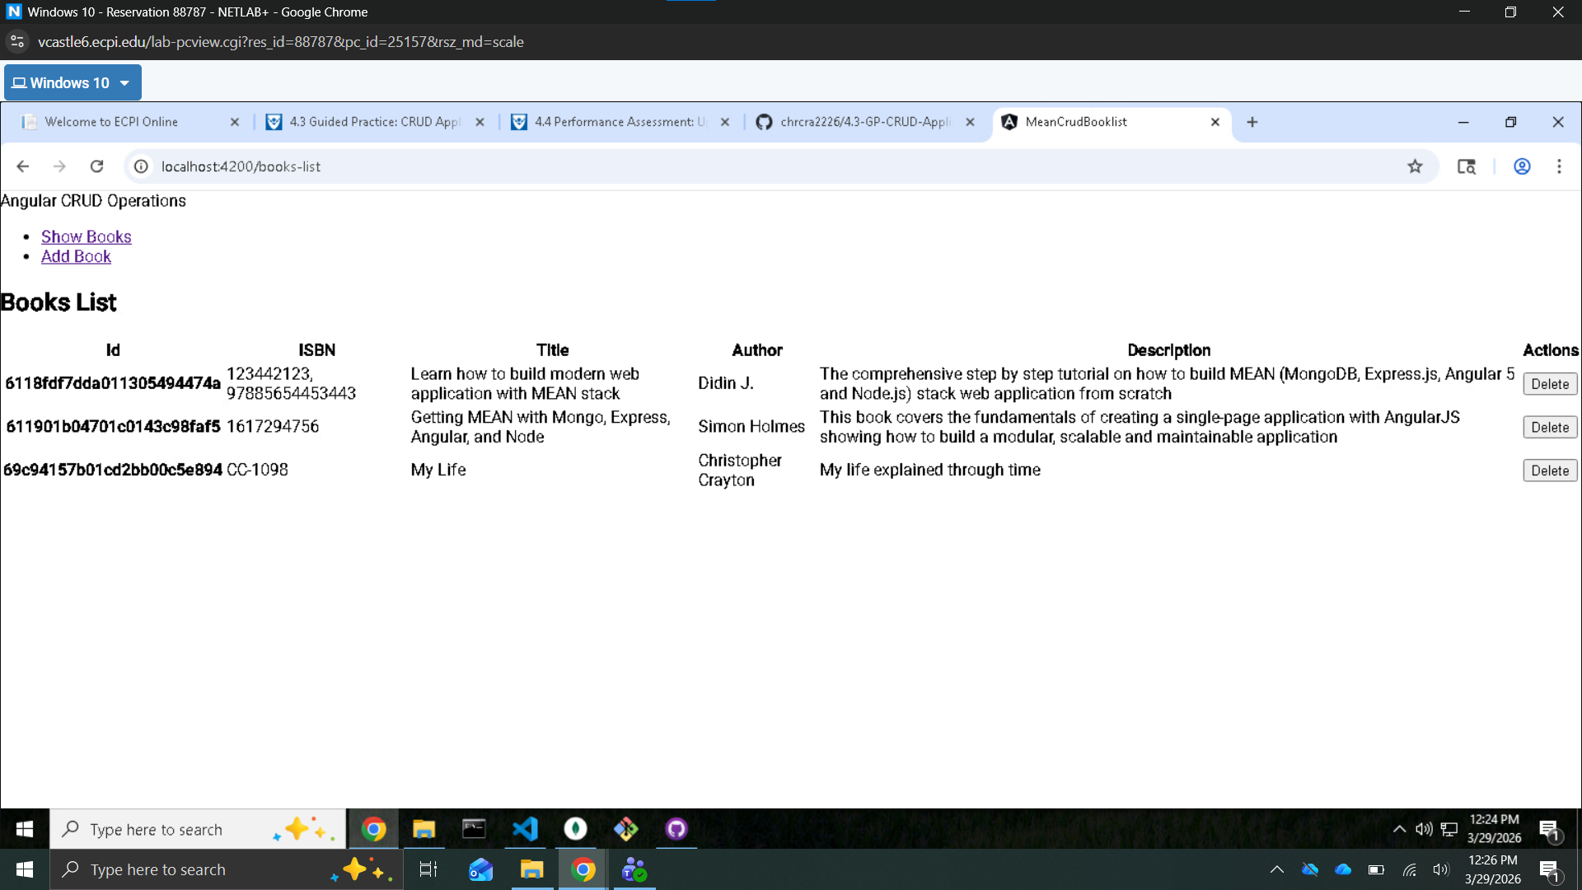
Entry Deleted:
